**PRACTICAL**

Configure NFS server to share directories on your NFS, Configure NFS Client. (Ubuntu and Windows Client OS)

**Install the NFS Kernel Server**

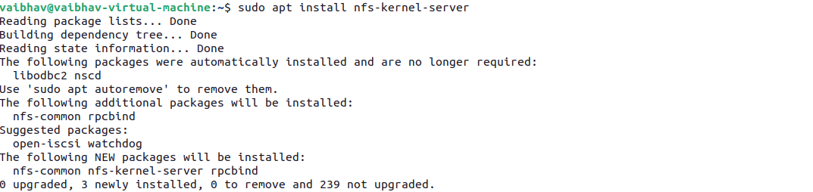

You need to specify which directory you want to share with clients. For example, create a shared directory:



Proper permissions must be set to control who can access the shared directory. You can set the permissions to allow all clients to read and write, or restrict them.



* nobody:nogroup ensures anonymous access.
* chmod 777 allows full read, write, and execute permissions for everyone.

The /etc/exports file defines what directories are shared and the access permissions for each clien



Add the following line to specify the directory to be shared and its permissions:

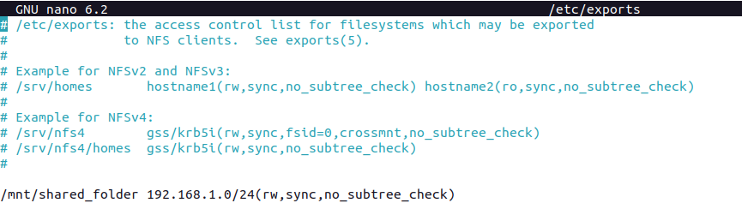

* /mnt/shared_folder: The directory to be shared.

192.168.1.0/24: The IP range of clients allowed to access this share.

(rw,sync,no_subtree_check): Options that allow read/write access (rw), ensure data is written to disk immediately (sync), and disable subtree checking to improve performance.

This step makes the shared directory available to the NFS clients.



If you're using the ufw firewall, you can open these ports by running the following commands:

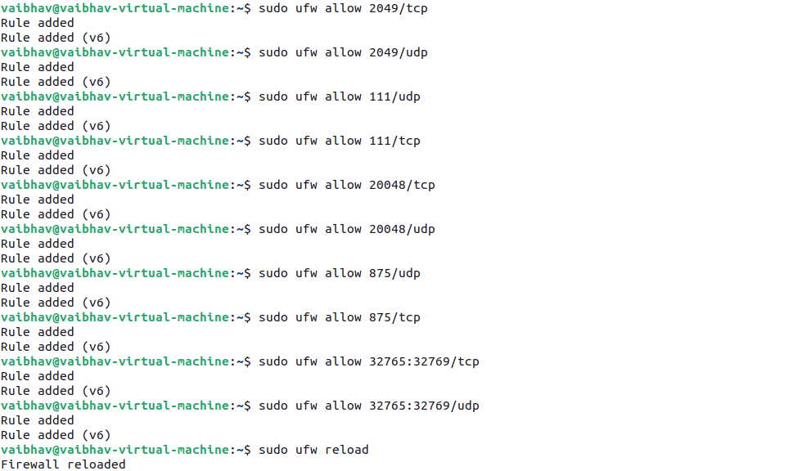

You may also need to open ports in the range 32765-32769:c



CLIENT:

The client system needs the nfs-common package to mount NFS shares.

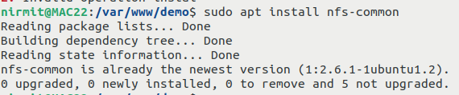

This is where the NFS share will be mounted on the client system.



Mounting the share allows you to access the files from the NFS server.



Check sync files

